**Lecture 18 Notes:**

**Lect 18 – Goals for today’s lecture**

1. Drag force for low Re (creeping flow)
2. Intro. To Lift Force
3. How to calculate lift force & factors affecting lift force
4. Relationship between CD and C L
5. The concept of stall
6. Role of flaps in changing CD and CL
7. Finite versus infinite wing and the effect on CD and CL

**Drag Force in Creeping (Stokes’) Flow (Re<<1)**

When Re<<1

1. Acceleration terms in N.S. Eqs. Are negligible
2. Viscous stream, is dominant🡪 since high

Momentum eq. simplifies due to 1) as: , continuity incomp. Fluid

For simple shapes above eqs. Can be solved as they are linear O.D.E’s

Stokes solves them for a sphere and found CD theoretically as:

, 🡪 dia. Of sphere, 🡪 sphere in creeping flow

Accounts up to

🡪 dia. Of sphere

See problem 7.725

**Lift Force:**

* Lift force is the force that an object in an external flow experience in the normal direction to the drag force.
* Unlike drag force that is mostly to be avoided (reduction of losses), lift force is a desirable force. Drag is only useful to stop an object. E.g., parachute
* Lift force is usually associated with useful work.
* Note: If lift force is in the negative y direction, sometimes it is called downforce

* The lift force allows an airplane to take off and remain afloat in the air or a wind turbine to twirl and produce mechanical work to run a generator.

Moment around a lift force axis is called yaw.

**Lift Force Resulted from Pressure Differences:**

* Lift force is normally produced as a result of pressure differential between two sides of the object w.r.t. the drag force plan
* If the 2D body is symmetric w.r.t. incoming free stream flow no lift is produced as Ptop=Pbottom

* If the 2D body is not symmetric w.r.t. incoming flow, then lift is produced

**Lift Force Calculation:**

Lift coefficient(CL) concept is used to calculate Lift Force (L) similar to CD used for drag force calculations but the area used is diff.

where 🡪 platform(ex. Wing area)

is found by experiments (eg. NACA NASA has a large publicly available values) or by CFD

**What affects** ?

* Re, α, and shape (similar to CD)
* For airfoils or hydrofoils, there is a sweet spot where CL is max and CD is min to produce the max work or performance

*For common airfoils:*

See Figs. 7.24 & 7.25

A pilot usually wants to fly at 1.2Vs, where Vs🡪 stall value and α<12°

*Recall: The use of flaps were to increase the lift at lower vel. So for ex., stall can be avoided. (stall was significant loss of lift force due to a) redirection of speed b) angle of attach)*

Theoretically it can be show that:

1. (CL Theory)🡪 where 🡪 deg., 2h🡪max. combos, c🡪 chord length (1)

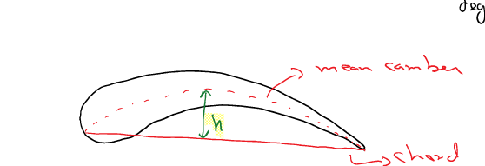

Stall Vel: , 🡪 lift, W🡪 weight, CL🡪 max

, CL🡪 max

**Two Complicating Factors for Lift Force Calculation:**

1. Tapered wing shape

*b*🡪 span of wing

1. Finite span

The CL values in plots are for a 2D airdoil (infinite span)

Aspect Ratio = AR =

AR can come α to increase (effective )

(2)

Combining Eqs. 1 & 2

The associated drag increase is

Or , 🡪 infinite span

**Figs Chap 7:**

*Nozzle:*

Decreasing

pressure

and area

Increasing

velocity

Favorable

gradient

*Throat:*

Constant

pressure

and area

Velocity

constant

Zero

gradient

Diffuser:

Increasing pressure

and area

Decreasing velocity

Adverse gradient

(boundary layer thickens)

**Figure 7.24**

**Figure 7.25:**

**Figure 7.26:**

**Flaps:**

**Figure 7.28:**

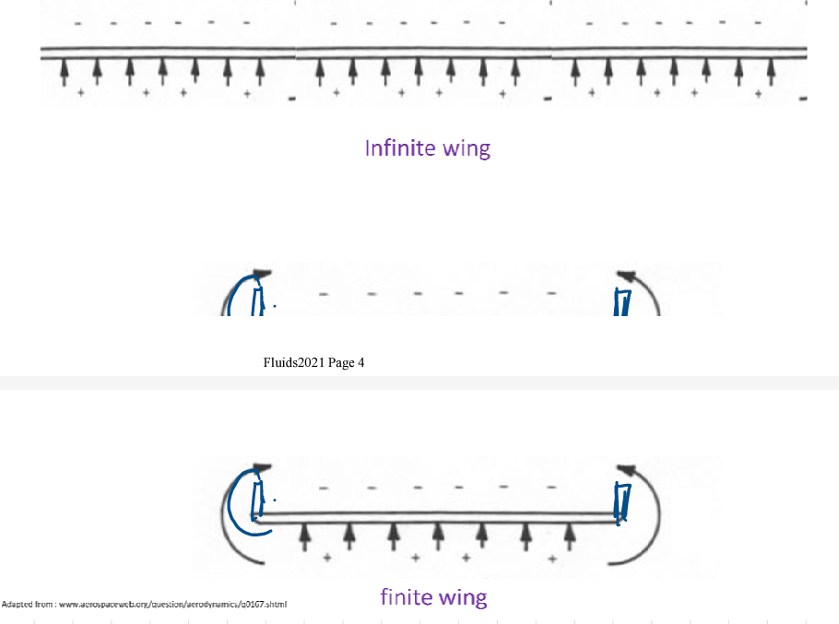

**Finite wing Versus Infinite Wing:**

Two benefits of wing let increase lift (a bit), decrease drag by weakening the vorticious

* Wing let (reduces vortex)
* Done poorly winglets, can increase flow separation and skim drag despite the feet that vorticious one reduced.

